Software Requirement Specification Document

For

Fake document detection system (FDDS)

Table of Contents
Page Numbers
- Introduction 3
  - Purpose 3
  - Intended Customers/Users 3
  - Product Scope 4
  - Outline of the document 4
- Overall Description 4
  - Product Perspective5
  - Product Functions5
  - User Classes6
  - Design and Implementation Constraints7
- Diagrams
  - UML Diagrams 7
  - ER Diagrams21
  - DFD Diagrams 22
- External Interface Requirements/Screenshots 23
  - User Interfaces 23
  - Hardware Interfaces 23
  - Software Interfaces 24
  - Communication Interfaces 24
- Other Non-Functional Requirements 24
  - Performance Requirements 24
  - Safety Requirements 25
  - Security Requirements 25
  - Software Quality Attributes 25
  - Business Policies/Rules (if any) 26
- Testing
  - White-Box Testing 26
  - Black-Box Testing 31
- Conclusion 40
- References
- Acknowledgements

- Introduction
  - Purpose
- Digitally converting sensitive records at an unprecedented rate has caused document forgery and credential fraud to spike to alarming levels, and thus, the need for a more secure verification infrastructure has become critical.
- The idea behind this project is to build a trust bridge by doing away with vulnerable centralized databases and replacing them with a decentralized Blockchain ledger that cannot be overwritten or manipulated by hackers.
- In an effort to detect the tiniest document tampering, the system employs the SHA-256 cryptographic algorithm to create a digital fingerprint unique to each file.
- SHA-256 is used to make sure that even the slightest change in a document will lead to a completely different hash, thus providing absolute and immediate proof of the alteration.
- Thus, the system achieves a verifiable document trust environment that is open and "trustless" using these technologies which means that any party can instantly verify a document’s authenticity.
- By creating a permanent, time-stamped audit trail on the blockchain, the project finally eliminates the problem of lost or manipulated ​‍​‌‍​‍‌records.

  - Intended Customers / Users
- This explanation is about a secure framework based on Blockchain and SHA-256 which is a system for detecting and preventing document forgery.
- It also goes deep into the technical details of how cryptographic hashing works and how Smart Contracts are used to keep an unchangeable record of the authentication of documents.
- The report also includes the system's design, the process of verification, and the security measures put in place to ensure the platform's data is trustworthy throughout.
- This paper is a resource for system administrators and developers who need to have a technical knowledge of how the decentralized ledger works with digital file signatures.
- It is an implementation manual for educational institutions and legal authorities that want to realize a transparent, automated system of certificate, license, and document verification.
- The report also hosts important information for both end-users and verifiers who wish to learn how to authenticate documents without the need for a ​‍​‌‍​‍‌third-party intermediary.

  - Product Scope
- The​‍​‌‍​‍‌ system uses the SHA-256 algorithm to generate a unique digital fingerprint for each file. Thus any change in the document will be very obvious immediately.
- These hashes are put publicly on a blockchain ledger to form an unalterable and everlasting record that serves as a time-stamped proof of existence.
- A verification unit that is specially designed for the purpose is there so that the users may upload a document, see its live hash, and cross-check the hash against the blockchain data without any human intervention.
- Smart contracts handle the registration process automatically and take care of the rules that govern the adding and usage of document hashes on the blockchain network.
- The system comes with an authorized issuer dashboard through which an institution like a university or a government office may digitally sign and upload document hashes for the public's verification.
- In order to keep data private and at the same time to lower the network cost, the project decides to store only the 64-character hash on the blockchain instead of the entire document content.
- The user gets a clear status message from the application indicating if the document is authentic, has been modified, or not found in the ​‍​‌‍​‍‌database.

  - Outline of the Document
    - ​‍​‌‍​Introduction and Problem Statement: This paragraph briefly discusses the forgery of documents and the need for a decentralized verification system.
      - The SHA-256 Hashing Mechanism: Here is a technical explanation of how documents are turned into one-of-a-kind, fixed-length digital fingerprints.
      - Blockchain Integration and Storage: Information about employing smart contracts to permanently record hashes on a tamper-proof ledger.
      - System Architecture Design: The diagram shows the connection between the user interface, the hashing engine, and the blockchain network.
      - Verification and Validation Logic: The method of checking that the uploaded documents are the same as the ones recorded on the blockchain is described here.
      - Implementation Results and Conclusions: A brief overview of the platform's performance, security advantages, and possible ​‍​‌‍​‍‌extensions.
2OVERALL DESCRIPTION
- Automated​‍​‌‍​‍‌ trust system: An automated platform that replaces manual document verification with a cryptographic process that guarantees the authenticity of documents.
- Digital fingerprinting: Refers to the use of SHA-256 technology to confirm that every document is a unique entity and its identity will change if even a single character is modified.
- Decentralized security: Uses blockchain to generate an immutable record of documents which is indelible and cannot be deleted or modified by any single entity.
- Instant validation: Has an intuitive interface that allows third parties to check the authenticity of a document in real-time without having to contact the ​‍​‌‍​‍‌issuer.
2.1Product Perspective
- System​‍​‌‍​‍‌ Context: Basically, this app works as a decentralized verification layer that links documents' issuing authorities (such as universities or government offices) with third-party verifiers (such as recruiters or banks).
- Independent Operation: Even though the system could be a standalone web application, its main purpose is to be a module that is integrated into existing Enterprise Resource Planning (ERP) or Student Information Systems.
- Blockchain Ecosystem: The product is based on a distributed network (for example, Ethereum or a private Hyperledger) to provide the tamper-proof storage required for document hashes, thus turning away from point, vulnerable databases.
- External Interfaces: The system makes use of external blockchain wallets (such as MetaMask) for unlocking transactions and can also employ decentralized storage protocols like IPFS to keep documents available without a centre server.
- Problem Domain Fit: This technology comes under the cybersecurity and identity management umbrella and its main focus is on the worldwide problem of credential fraud and the high cost of manual background checks.
- Constraints and Dependencies: The efficiency and cost of the product are tied to the basic blockchain’s transaction speeds (latency) and network fees (gas ​‍​‌‍​‍‌prices).
2.2Product Functions
- Secure​‍​‌‍​‍‌ hash generation: The software obtains any document submitted, then generates a unique hash fingerprint using the SHA-256 algorithm that acts as a one-to-one representation of the file's contents.
- Blockchain registration: Issuers who have been given the green light can store the generated hash on a blockchain ledger in a permanent, completely tamper-proof and timestamped manner, hence creating an undeniable proof of the document's existence.
- Real-time verification: The publicly available search feature enables anyone to upload a digital file and compare its hash with a record on the blockchain. This is the direct proof of the document's authenticity.
- Tamper detection: There can be no doubt about forgery if the system physically refuses a paper to be verified when it carries a different hash than the one that was registered.
- Digital signature management: In order to guarantee the origin is trustworthy, the platform employs cryptographic keys to authenticate the organization that is issuing a certain instrument.
- Status reporting: Once a check has been completed, the system provides an unmistakable report with the results indicating whether a document is authorized, modified, or non-existent in the ​‍​‌‍​‍‌database.
2.3 User Classes
- Issuing Authorities (Universities and Institutions): These actors serve as the ultimate source of truth. They simply create the system to upload digital documents or transcripts, generate a unique SHA-256 hash for each of them, and sign the transaction with a digital signature to record the hash on the blockchain.
- Government Regulatory Bodies: Government entities utilize the platform to verify official identities, licenses, and permits. By being the root authorities that can authenticate the most fundamental credibility of the issuing institutions, they essentially provide an additional level of trust.
- Document Holder (Students or Citizens): These are individual users who hold the documents. They employ the system to keep their digital certificates in a safe wallet and share the document or its unique hash ID with third parties for confirmation without having to ask for physical copies again.
- Third Party Verifiers (Employers and Banks): These users access the public verification portal. The system re-hashes the uploaded document presented by a user and automatically compares it to the record on the blockchain to verify that the document has been unaltered since the issue date.
- System Administrators: These are technical users who take care of the platform’s infrastructure. They are mainly in charge of updating the smart contracts, managing the list of authorized issuing institutions, and making sure that the interface between the web application and the blockchain network is always working.
- Auditors and Legal Entities: They rely on the blockchain’s immutable ledger to examine the entire history of a document. They have an unerasable, timestamped audit trail at their disposal, recording the document’s creation, issuance, and any further modifications such as revocations or ​‍​‌‍​‍‌renewals.
2.4Design and Implementation Constraints
·​‍​‌‍​‍‌ Blockchain network latency: The rate at which a document can be registered is bound to the block time of the blockchain network, thus, the users might feel a delay from the time they submit a document until a confirmation of the document is done on the ledger.
· Gas fees and transaction costs: A fee is always required for each write operation on a public blockchain, which establishes a financial limitation on the number of documents that can be registered or updated by an institution.
· Immutability of data: The unchangeable nature of data on a blockchain makes it impossible to delete any errors made during the hashing or registration of which are therefore permanent, and that is why the data entry and pre-verification must be very accurate.
· Storage capacity limitations: Blockchains are not intended for the storage of large files and hence the resulting system can only store 64-character SHA-256 hashes while the actual document files are kept in the external databases or IPFS which it relies on.
· Smart contract security: The security of the smart contract code limits the implementation such that any vulnerability would result in unauthorized access or the lack of update of the authorized issuer lists.
· Interoperability requirements: It is necessary that the system be interoperable with different browsers and blockchain wallets so it should turn to using standardized APIs and protocols in order to provide a uniform user experience.
· Scalability of the network: The verification portal performance should not be compromised when the volume of the queries is increased as a result of the document number growth; the system must be able to address such a situation.
· Legal and regulatory compliance: The implementation is of course necessary to be in agreement with the data protection laws such as GDPR and it must be ensured that while hashes are public, no personally identifiable information will be stored directly on the transparent ​‍​‌‍​‍‌ledger.

3. Diagrams
3.1 UML DIAGRAMS
a) Use-Case Diagram
🔹Module 1: User & Document Management Module
Purpose: Handles users and document uploads.
Responsibilities:
- User registration & login
- Role management
- Upload documents
- Store document metadata
Primary Actor ->A1. User

Secondary Actor -> S1. Administrator
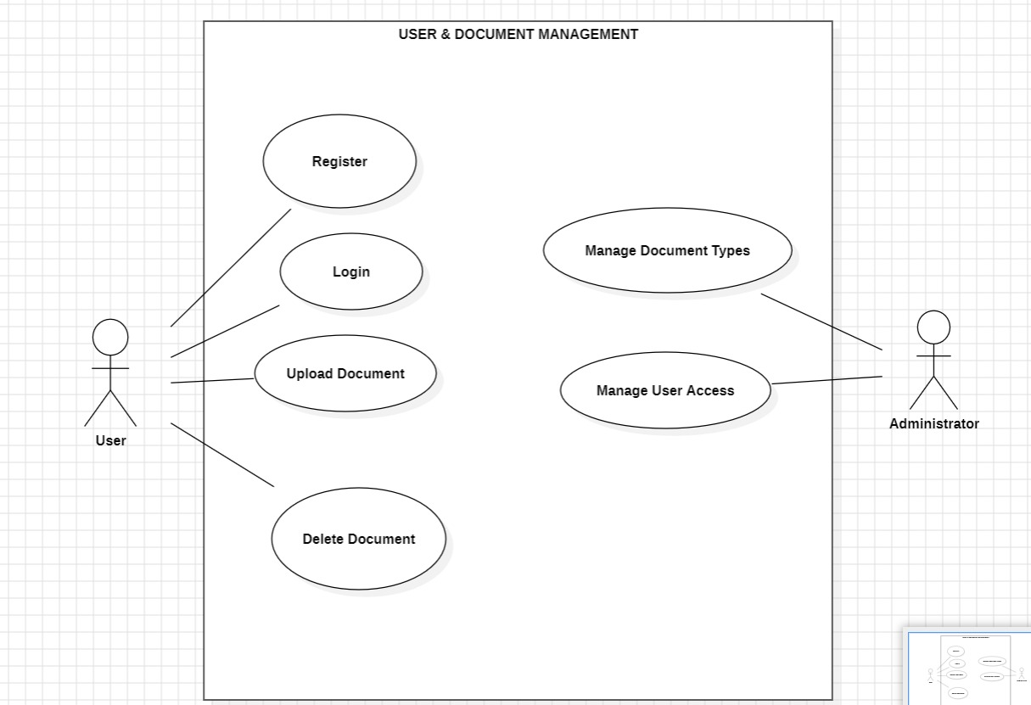

Module 2: Fake Detection & Verification Module
Purpose: Core logic to detect forgery.
- Receives extracted features
- Runs verification logic
  - Machine learning model checks patterns
  - Rule-based system checks predefined fraud rules
- Calculates authenticity score
- Gives final decision
  - REAL or FAKE
  - With confidence percentage
  - Primary Actor ->User,Secondary Actor -> System
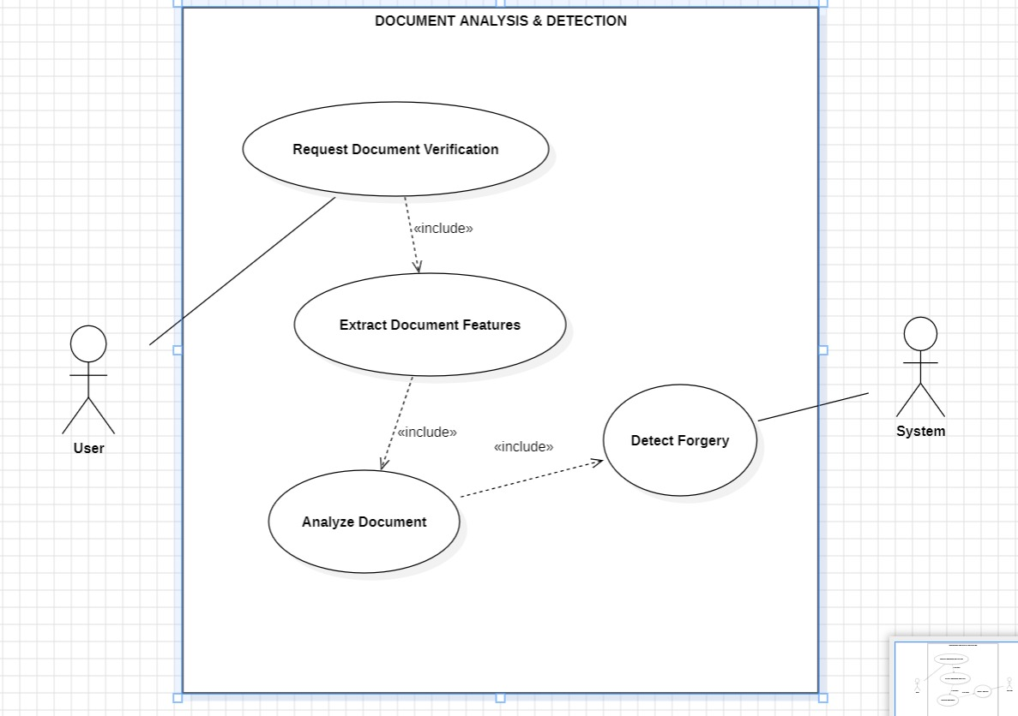
Module 3: Result Analysis & Reporting Module
Purpose: Show output & generate reports.
- Receives the verification result from the Fake Detection module
- Interprets the confidence score
- Displays the result to the user/admin
- Generates a verification report (PDF)
- Stores logs for future reference
Primary Actor ->User, Secondary Actor -> Admin, System
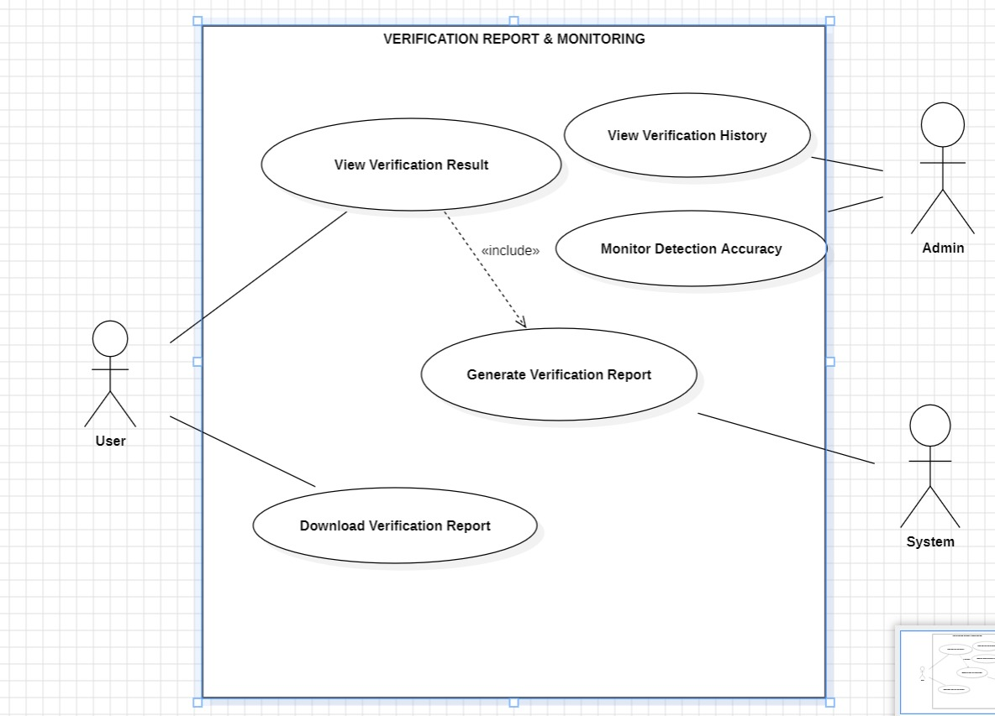

b)Class Diagram
🔹 Module 1: User & Document Management Module
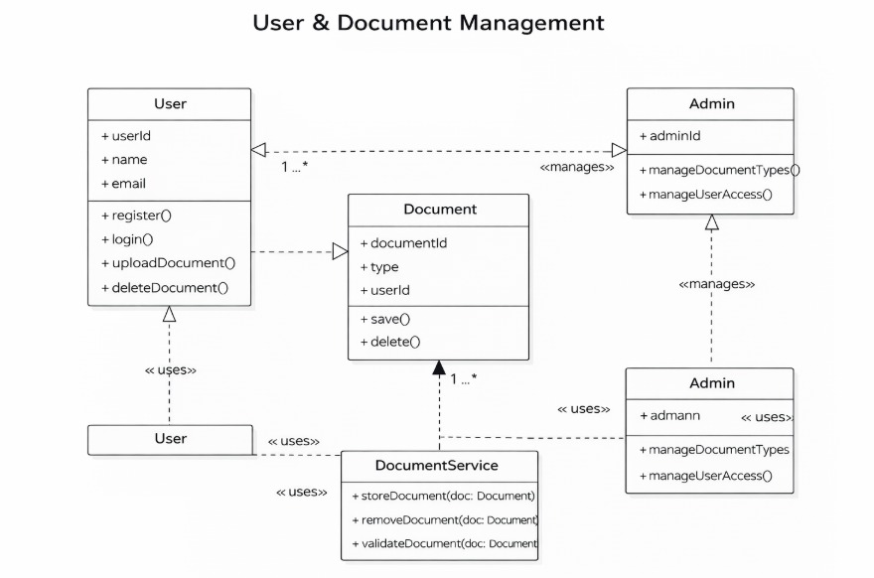
- Module 2: Fake Detection & Verification Module
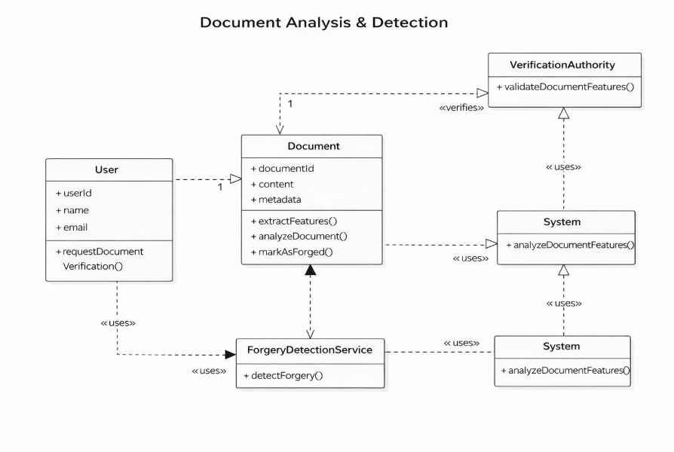
- Module 3: Result Analysis & Reporting Module
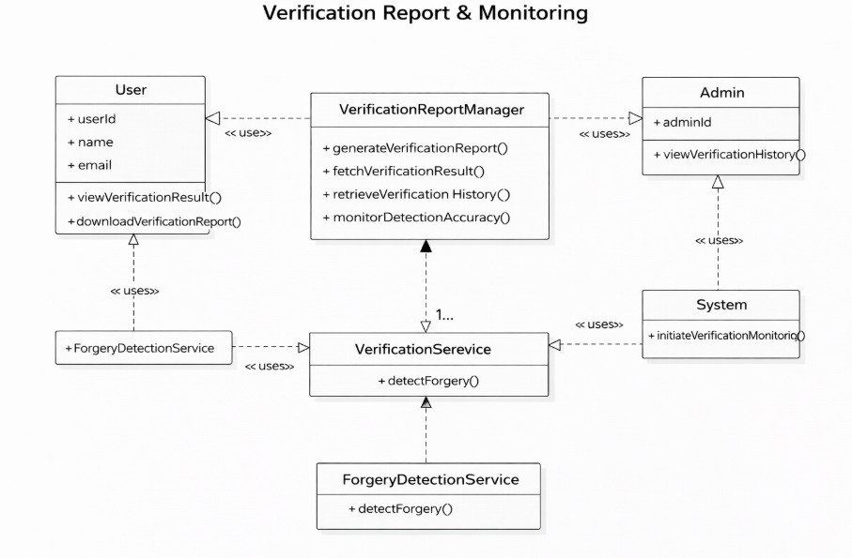
c) State chart Diagram(For Module 1):
1) STATE DIAGRAM 1 — User Authentication

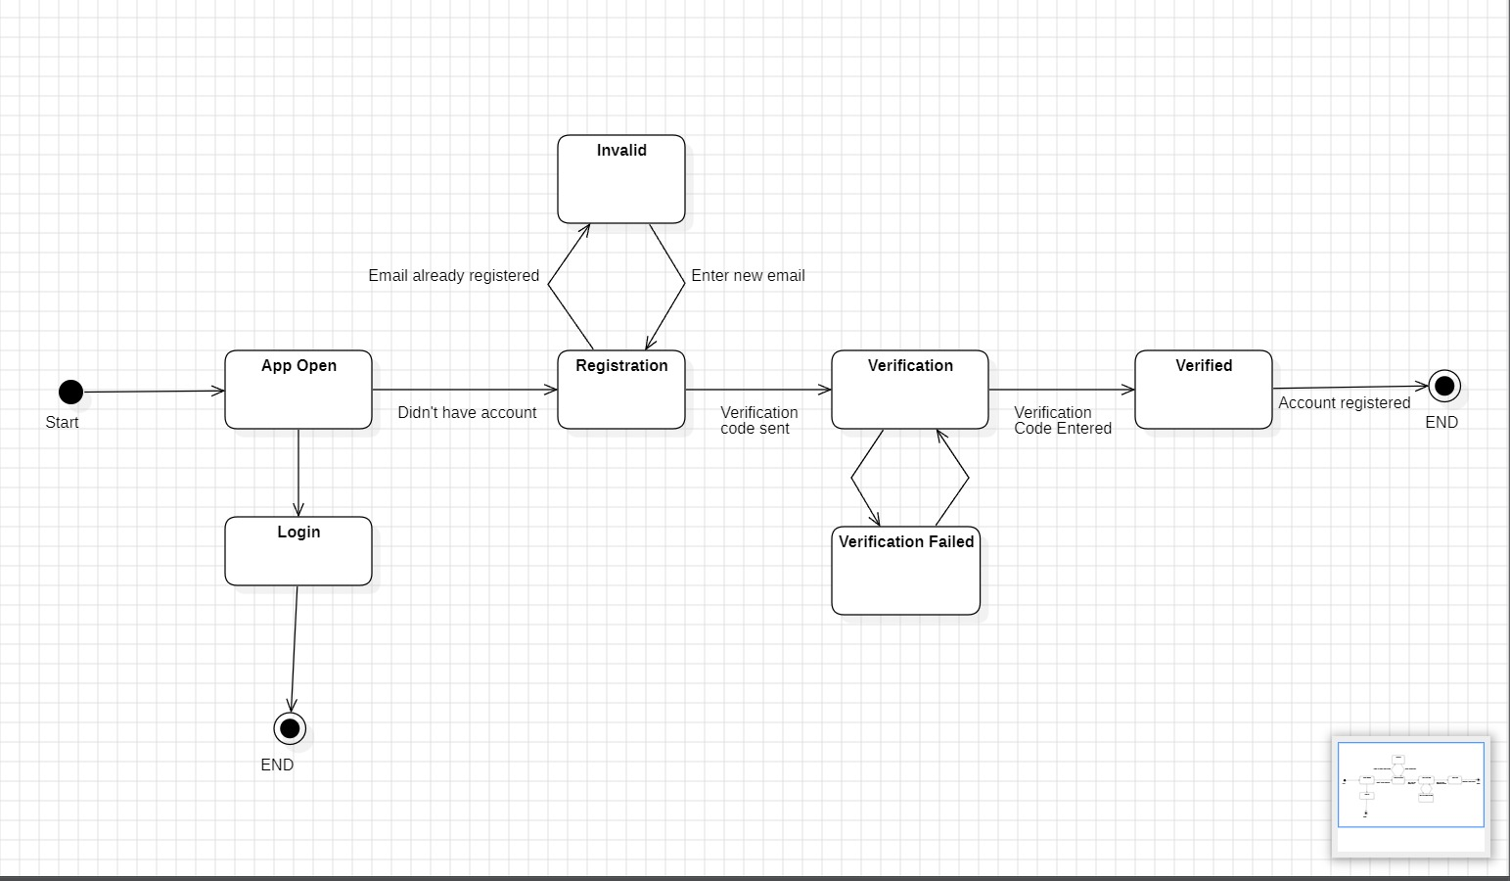
2) STATE DIAGRAM 2 — Document Upload & Delete
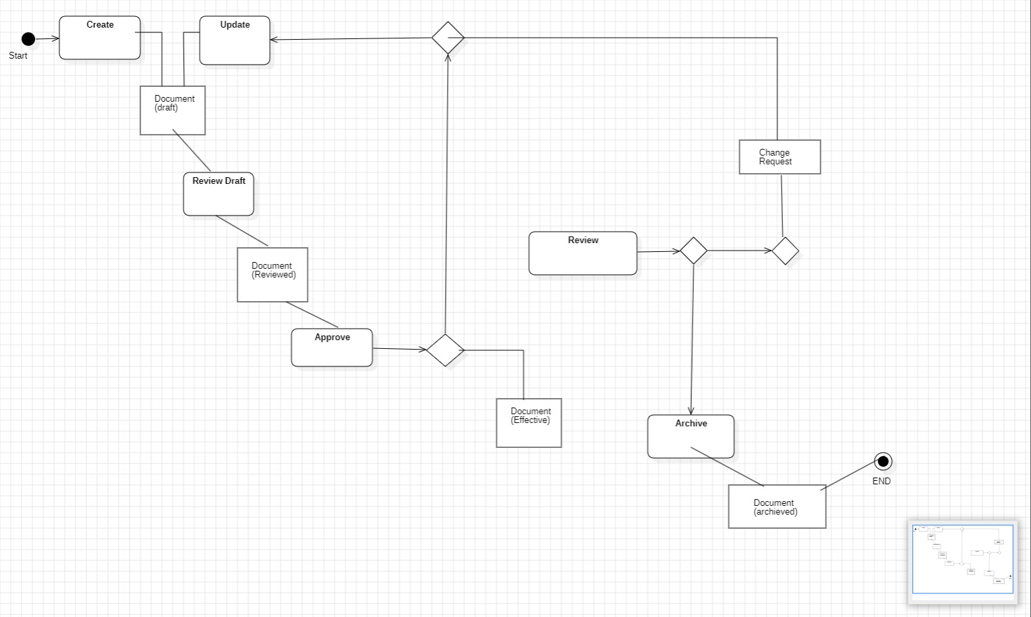
3) STATE DIAGRAM 3 - Admin User Access Control
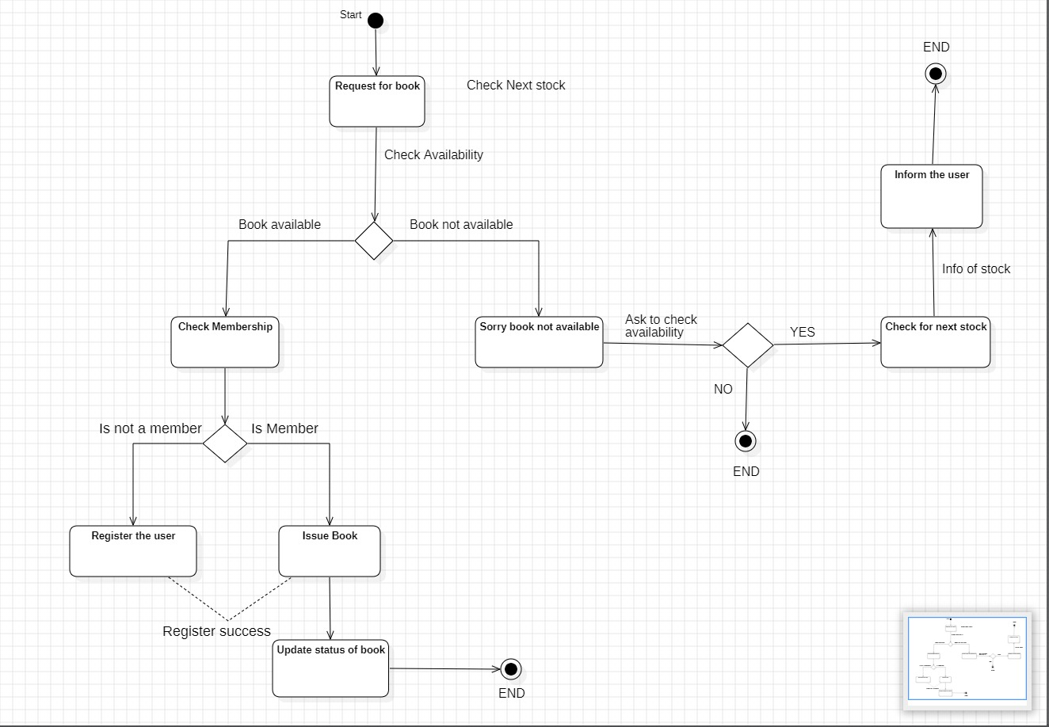
d) Activity diagram (for Module 1)
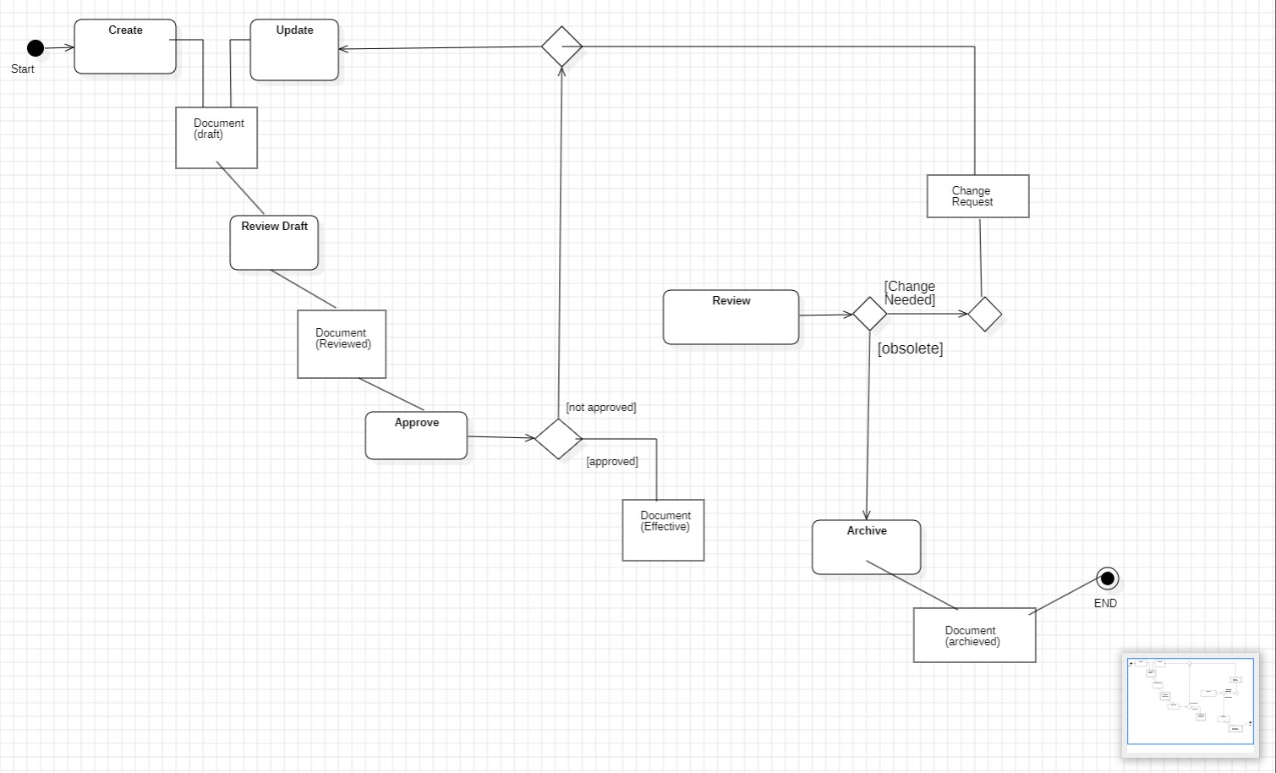
e) Sequence diagrams:-
i) Module 1: User and document management module
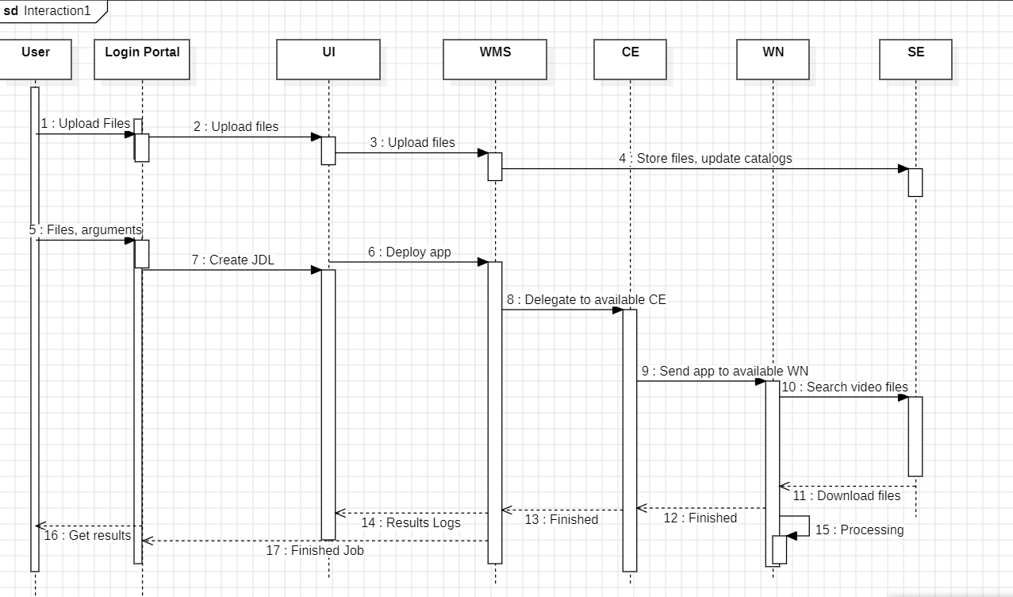
ii) Module 2: Fake detection &verification module
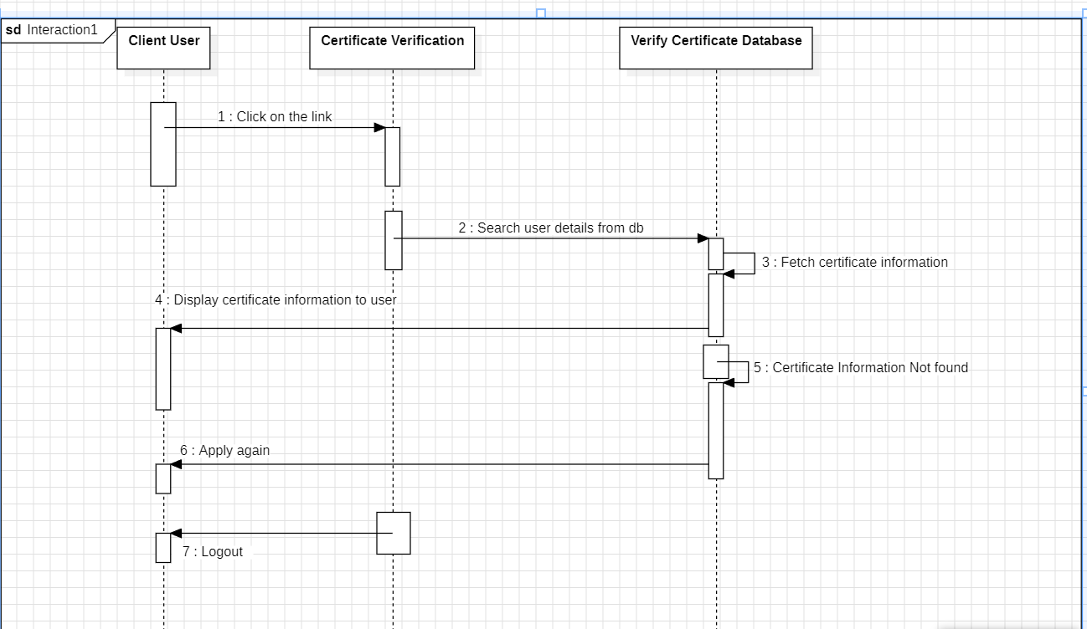
iii) Module 3: Result Analysis & Reporting module
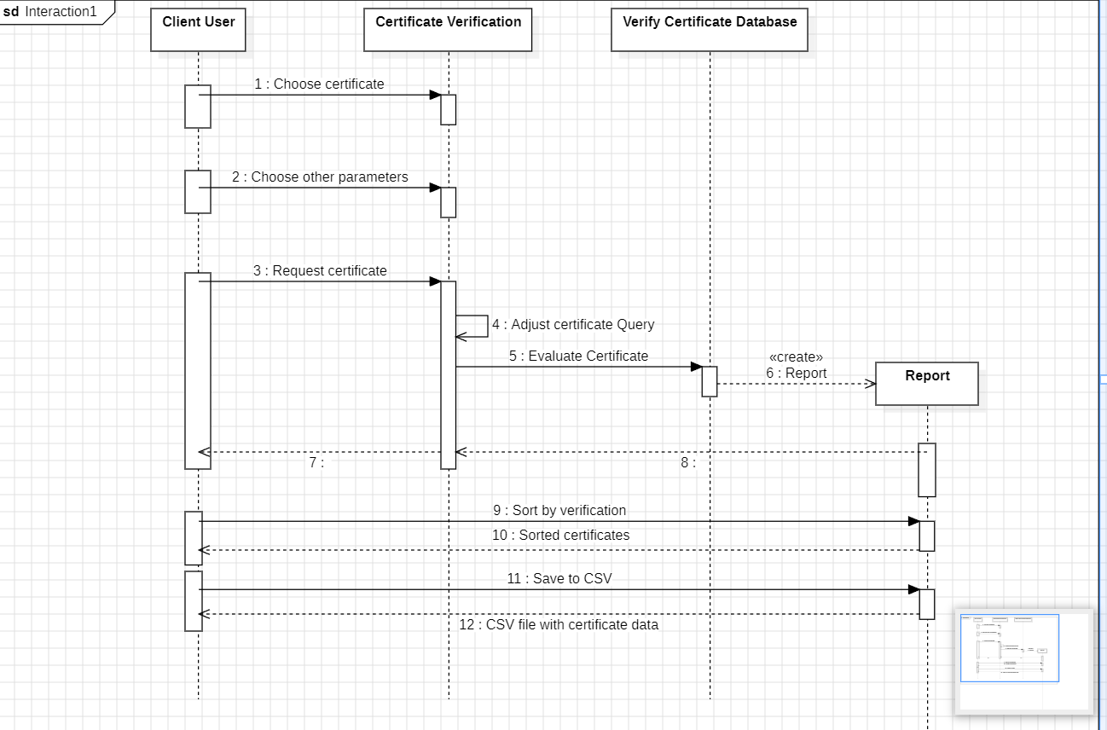
f) Collaboration Diagrams:

i) Module 1: User and document management module

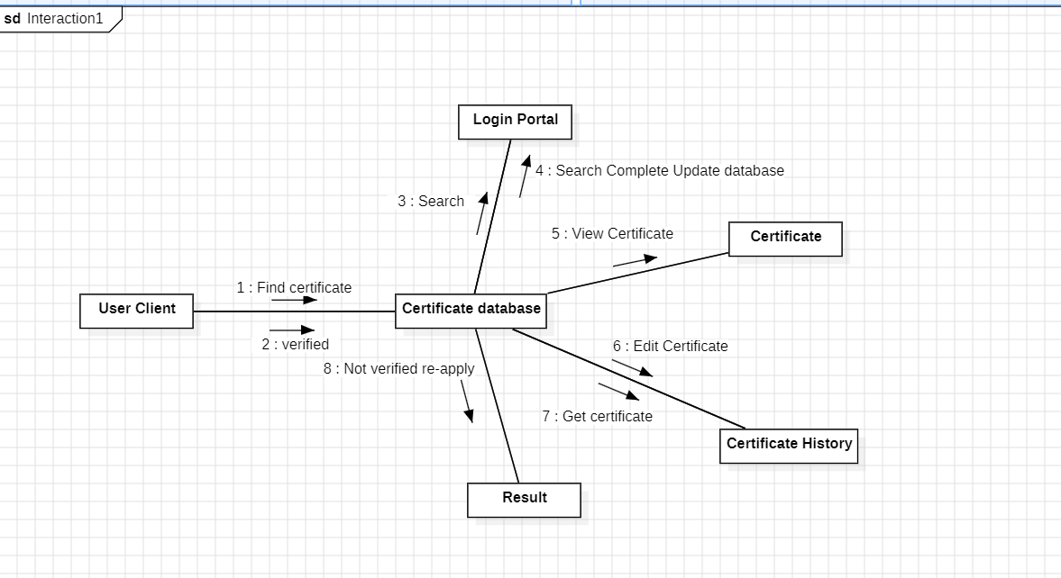

ii) Module 2: Fake detection & verification module
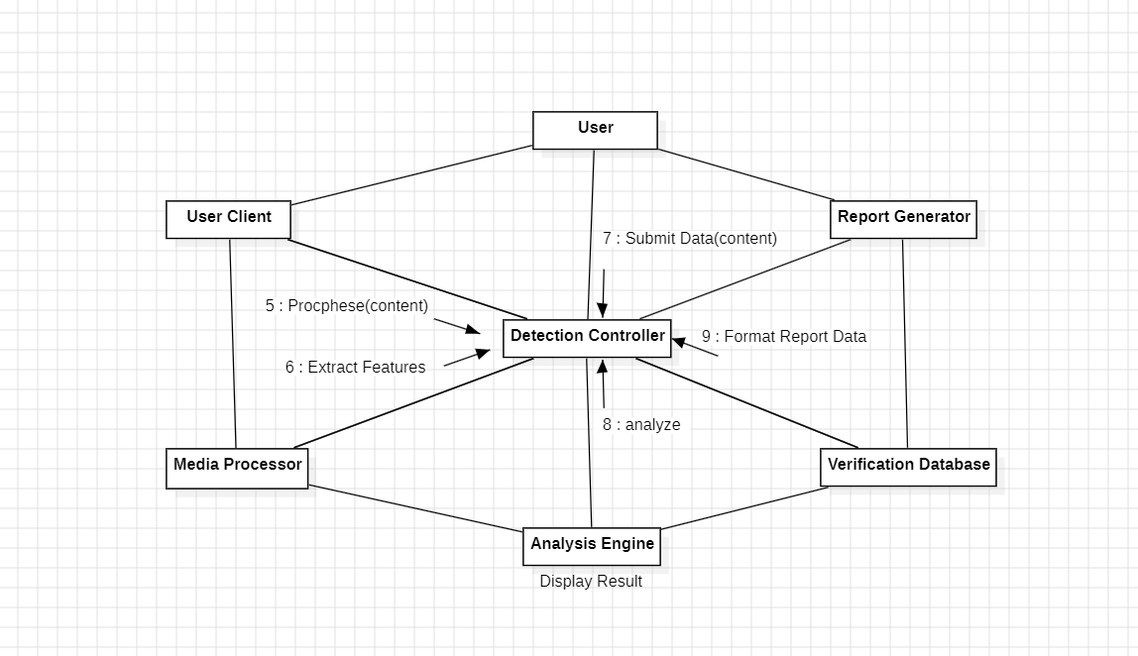

iii) Module 3: Result Analysis and Reporting Module
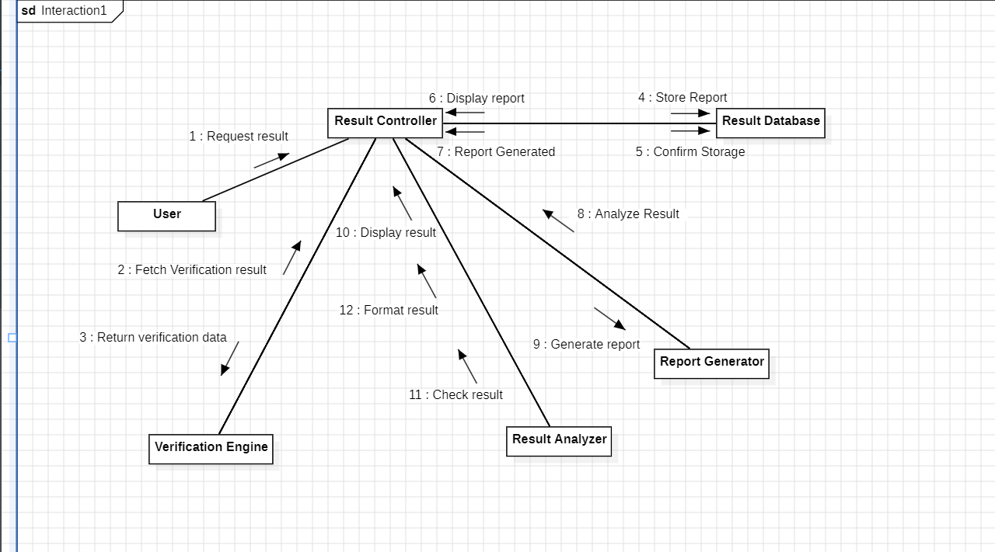

3.2) Entity-Relation Diagram:

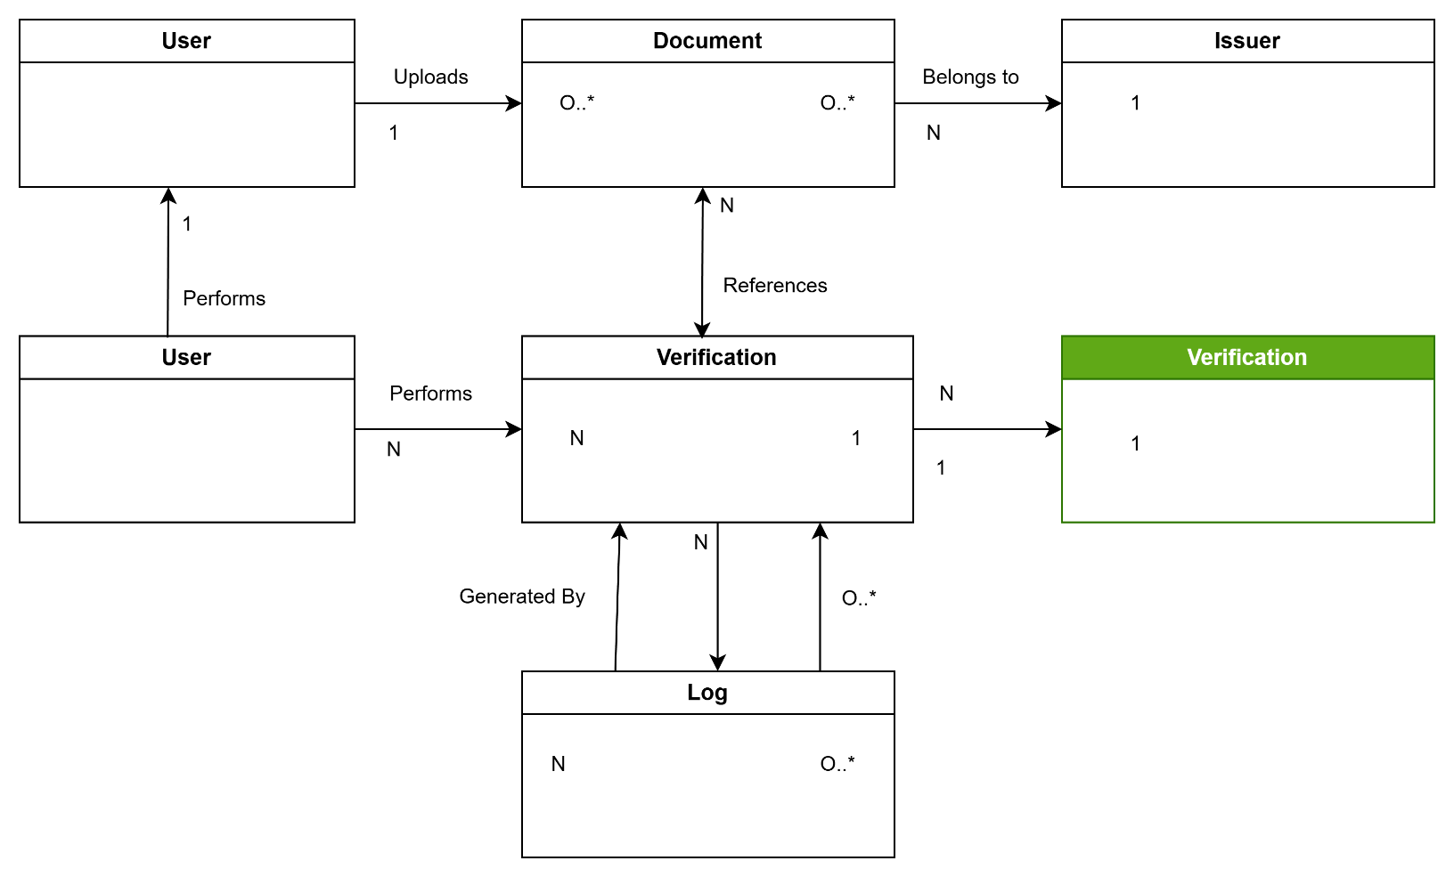

3.3) Data flow diagram:
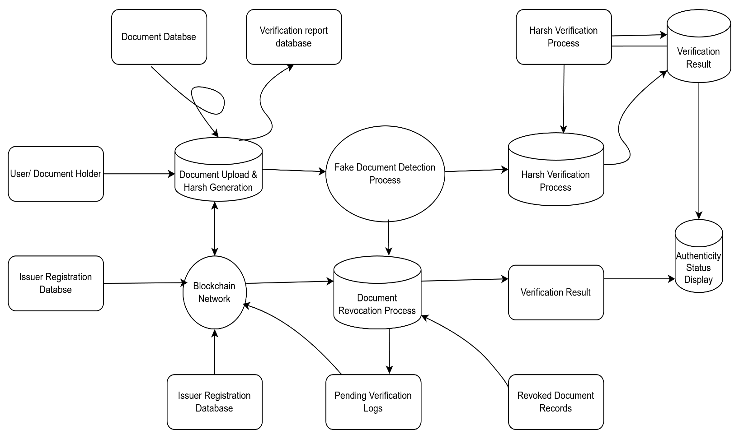
4. External Interface Requirements
This section details how the Fake Document Detection System (FDDS) interfaces with its users, hardware, software components, and communication networks. This set of interfaces allows seamless data exchange among the modules (User Management, Verification, Blockchain Integration, Reporting).

4.1User Interfaces
The User Interface will be straightforward, secure, and responsive so that institutions, document holders, and verifiers can easily interact with the system.

4.1.1 Login Screen
- Description: Provide authorized users (Admin, Issuer, Verifier, Document Holder) the opportunity to access the system.
- Components: Username text box, Password text box, Login button, Forgot Password hyperlink.
- Functionality: Verifies user credentials and sends them to their respective dashboard.

4.1.2 Document Upload Interface
- Description: The UI for users to upload documents so that the system can generate hash and verify it.
- Components: File upload button, Document type dropdown, Submit button.
- Functionality: Creates SHA-256 hash and forwards the data to a verification module.

4.1.3 Issuer Dashboard
- Description: It is a portal for an authorized institution to record document hashes onto a blockchain.
- Parts: Document upload feature, Digital signature verification, Status display.
- Operation: Records document hash on blockchain and saves the transaction ID.

4.1.4 Verification Result Screen
Description: This screen is used to show the people the result of authenticity.
Components: Status message (Authentic / Modified / Not Found), Confidence score, Download Report button.
Functionality: Displays the verification result and offers the option of report generation.

4.2 Hardware Interfaces
- The system needs to support desktop, laptop, and mobile devices.
- At least 4GB RAM along with support for a modern web browser is essential.
- For blockchain transactions, the user might have to use a crypto wallet hardware/software (e.g., MetaMask).
- For blockchain communication, it is necessary to have Internet access.

4.3 Software Interfaces
- Frontend: Web app developed with HTML, CSS, and JavaScript.
- Backend: A server-side app that deals with hashing and verification logic.
- Database: MySQL / MongoDB for storing users and metadata.
- Blockchain Platform: Ethereum / Hyperledger to hold document hashes.
- Cryptographic Library: SHA-256 hashing algorithm integration.

4.4 Communication Interfaces
- HTTPS protocol for secure web communication.
- API integration between frontend and backend.
- Smart contract interaction using Web3 APIs.
- Secure wallet connection for blockchain transactions.
- Encrypted data transfer using SSL/TLS.

5. Other Non-Functional Requirements
This part of the document spells out the quality standards, limitations, and working conditions that the Fake Document Detection System must meet apart from its functions.

5.1 Performance Requirements
- For standard document sizes (up to 10MB), the system shall be able to generate a SHA-256 hash within 2, 5 seconds.
- The time for response to verification should not go beyond 5 seconds, blockchain network latency not being factored in.
- The system shall be designed to handle multiple users concurrently (at least 100 verification requests simultaneously).
- Blockchain registration time is determined by network confirmation speed but shall give a notification to the user once the transaction is confirmed.
- The system shall be designed to be highly available (uptime of at least 99%).
- Database queries for verification logs and reports shall be made efficient for quick retrieval.
- When the number of stored document hashes increases, the application shall continue to scale smoothly.

5.2 Safety Requirements
- The system should guarantee that no content of an original document is stored on the blockchain; merely the 64-character hash is stored.
- An effective backup strategy should be put in place to back up user and metadata databases.
- Due to the decentralized nature of blockchain, no registered data should be lost even if the system fails.
- Proper error handling can significantly reduce the chance of accidental overwriting of document records.
- The system needs to maintain logs of all significant operations (upload, verification, revocation) for the sake of audits.
- Recovery operations need to be in place to bring the system back to normal after a server crash.

5.3 Security Requirements
- User authentication should always be performed with a secure login credential (username and password).
- Passwords should be encrypted or hashed before they are stored.
- Role-based access control should be used to limit system functions to specific roles (Admin, Issuer, Verifier, User).
- All communication should be done through HTTPS (with SSL/TLS encryption).
- Digital signature verification is required for blockchain transactions.
- The system should block any unauthorized changes of the stored hashes.
- The system should be protected from attacks such as SQL injection, XSS, and CSRF.
- Multi-factor authentication may be turned on for issuing authorities.
- Smart contracts should be subjected to testing and auditing to eliminate vulnerabilities.

5.4 Software Quality Attributes
Reliability
  - The software must always provide the most accurate verification results.
  - You can expect that hash comparison results will be one hundred percent deterministic.
Usability
  - The software interface should be so simple and easy to use that even non-technical users would have no problem understanding it.
  - There should be directive messages that clearly state whether a document is Authentic, Modified, or Not Found.
Maintainability
  - The source code is expected to be structurally modular to facilitate simple updating and debugging processes.
  - Version control shall be maintained for smart contracts and backend modules.
Scalability
  - The software should be able to accommodate an increase in the number of users and documents without any decrease in the performance.
Portability
  - The software should be optimized for Chrome, Edge, and Firefox browsers.
  - It should work well with the major operating systems (Windows, Linux, macOS).

5.5 Business Policies / Rules
- Only the authorized issuing institutions will be permitted to register document hashes on the blockchain.
- Due to the nature of blockchain immutability, a document hash cannot be removed after it has been registered.
- In case a document needs to be invalidated, it shall be pointed out as "revoked" rather than "deleted".
- Users need to accept terms and conditions prior to document submission.
- Personal data or PII will not be kept on the blockchain.
- The verification output will be the result of an automatic generation process without any human involvement.
- Each entity shall ensure its operations are in line with the data protection legislation requirements (e.g., the GDPR principles must be followed).
- If there are blockchain transaction fees (gas fees), they must be paid by the issuing authority.

6. Testing
6.1 White Box Testing
  - Functional Logic Code
import cv2
import pytesseract
def detect_document(image_path):
img = cv2.imread(image_path)
gray = cv2.cvtColor(img, cv2.COLOR_BGR2GRAY)
text = pytesseract.image_to_string(gray)
keywords = ["Government", "Certificate", "Official"]
for word in keywords:
if word.lower() in text.lower():
return "Document is Likely Genuine"
return "Document may be Fake"
result = detect_document("document.jpg")
print(result)

- Control Flow Diagram:

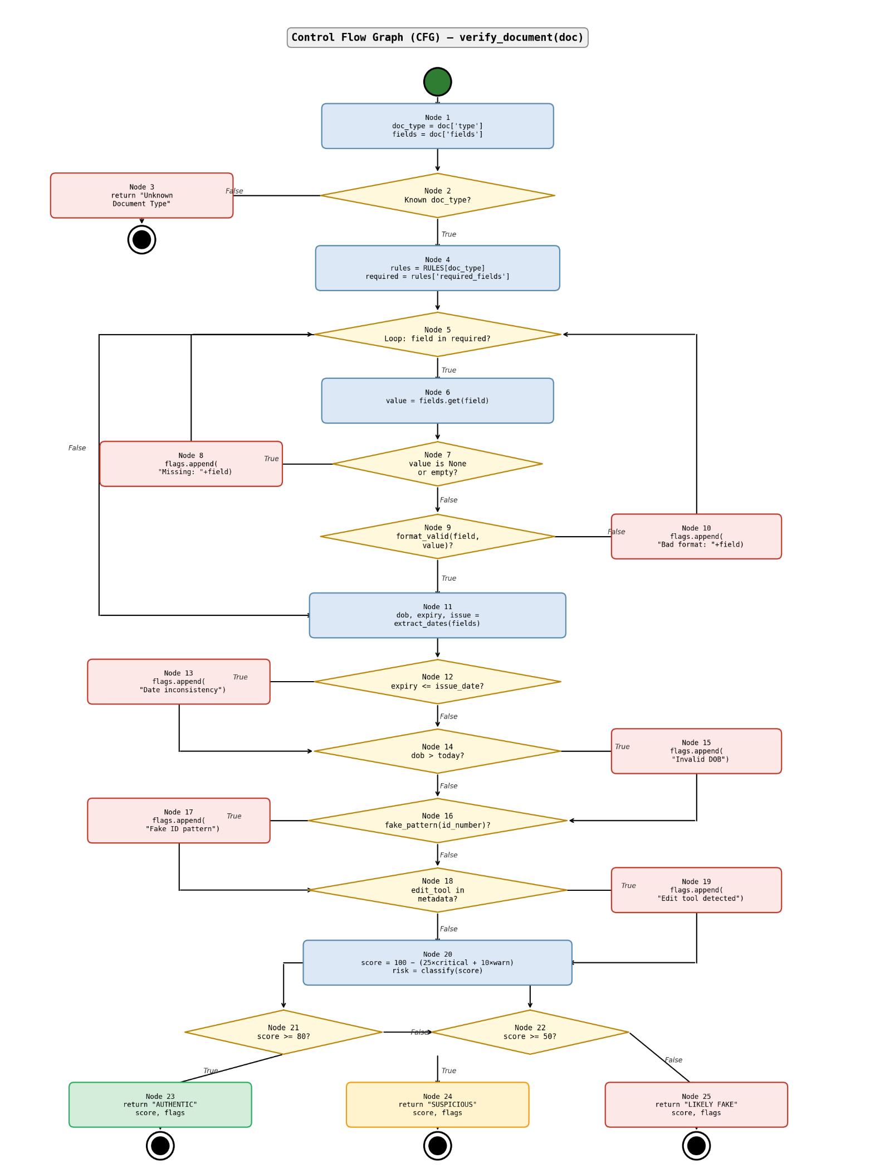

• Method 1: Using Predicate Nodes
The formula is V(G) = P + 1
Node 2, Node 4, Node 8, Node 11
Total Predicate Nodes (P) = 4
V(G) = 4 + 1 = 5

• Method 2: Using Edges and Nodes
The formula is V(G) = E − N + 2
N (Number of Nodes) = 16
(14 logic nodes + 1 Start node + 1 consolidated End node)
E (Number of Edges) = 19
V(G) = 19 − 16 + 2 = 5

• Method 3: Using Regions
Inner Regions = 4 (formed by the loop cycle and branching decision paths)
Outer Region = 1
Total Regions = Inner Regions + Outer Region
Total Regions = 4 + 1 = 5

- Independent Program Paths
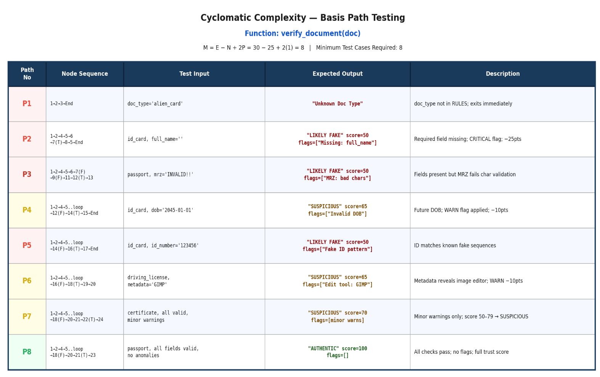

- Unit Testing Code:
import unittest
from detector import detect_document
class TestFakeDocumentDetection(unittest.TestCase):
# Test if function runs correctly
def test_function_execution(self):
result = detect_document("document.jpg")
self.assertIsNotNone(result)

# Test for genuine document detection
def test_genuine_document(self):
result = detect_document("real_document.jpg")
self.assertTrue("Genuine" in result)

# Test for fake document detection
def test_fake_document(self):
result = detect_document("fake_document.jpg")
self.assertTrue("Fake" in result)

# Test return type
def test_output_type(self):
result = detect_document("document.jpg")
self.assertIsInstance(result, str)
if __name__ == "__main__":
unittest.main()

6.2 Black Box Testing
  - Step 1: Functional Requirements
According to the specifications of the Fake Document Detection System, the document verification module has to comply with the following rules:
• The uploaded document should be in a valid image or PDF format (such as JPG, PNG, or PDF).
• The document image should be clear and readable for proper text extraction.
• In case the document file is invalid or corrupted, the system should send back an invalid document message.
• The system should extract text from the document using OCR for further verification.
• If the required official keywords or document patterns are detected, the system should classify the document as a Genuine Document.
• If the document does not contain expected information or patterns, the system should classify the document as a Suspicious Document.
• If the document contains significant inconsistencies or missing details, the system should classify the document as a Fake Document.
• Finally, the system should display the verification result to the user indicating whether the document is Genuine, Suspicious, or Fake.

- Step 2: Equivalence Class Partitioning (ECP)

  - Boundary Value Analysis (BVA)
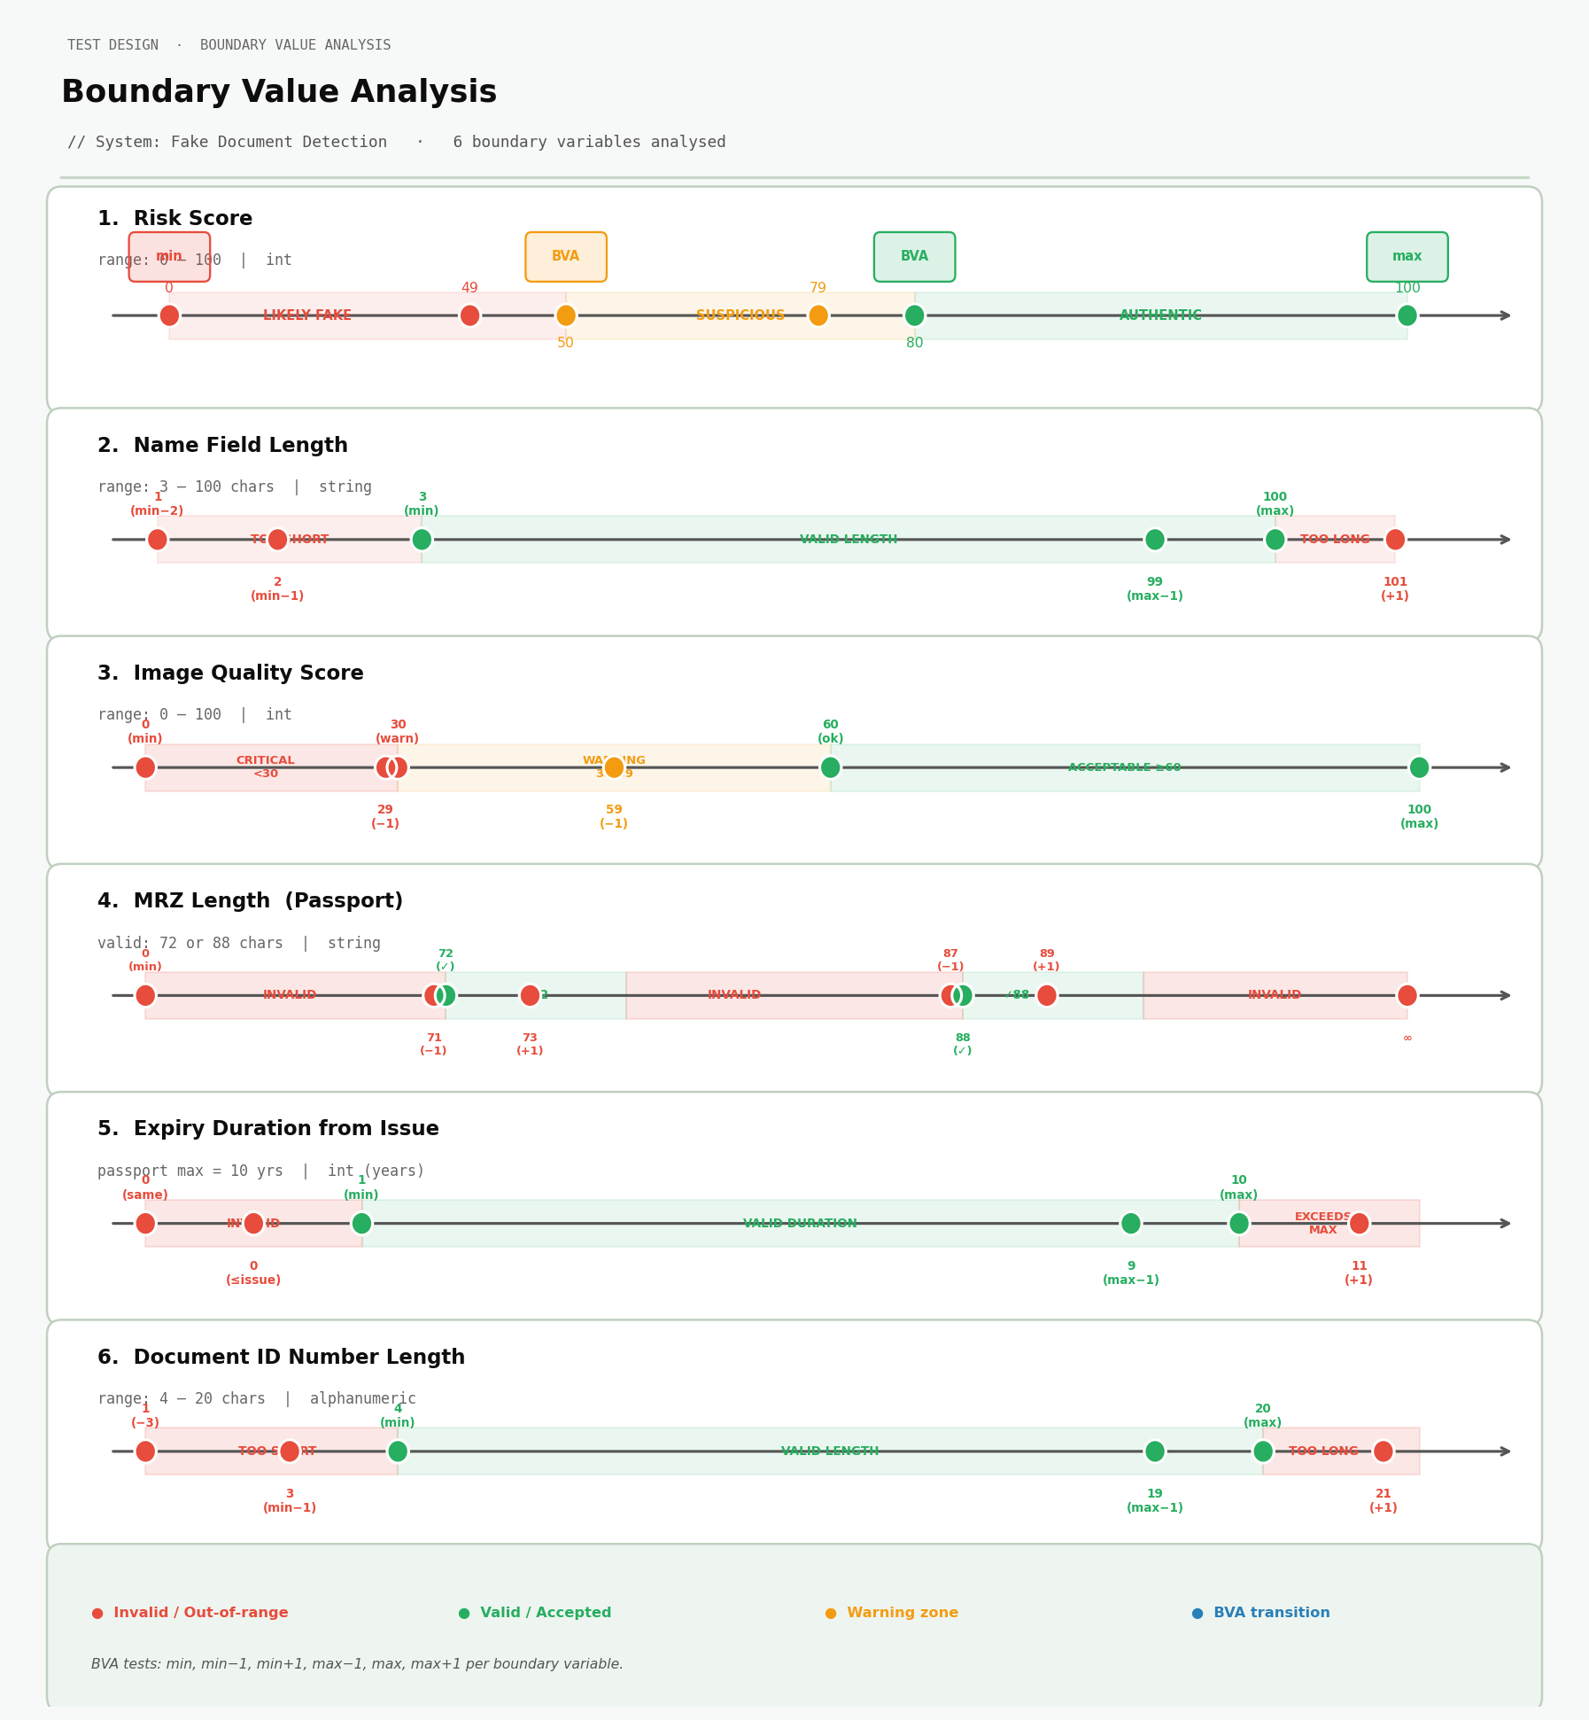

- Step 4: Execute the Black-Box Test Cases
import unittest

# Example validation functions (based on the boundaries shown)

def validate_risk_score(score):
if score < 50:
return "Likely Fake"
elif score < 80:
return "Suspicious"
else:
return "Authentic"

def validate_name_length(length):
return 3 <= length <= 100

def validate_image_quality(score):
return score >= 60

def validate_mrz_length(length):
return length == 72 or length == 88

def validate_expiry(years):
return 1 <= years <= 10

def validate_doc_id_length(length):
return 4 <= length <= 20

class TestFakeDocumentSystem(unittest.TestCase):

# Risk Score Boundary Tests
def test_risk_score(self):
self.assertEqual(validate_risk_score(49), "Likely Fake")
self.assertEqual(validate_risk_score(50), "Suspicious")
self.assertEqual(validate_risk_score(80), "Authentic")

# Name Length Boundary Tests
def test_name_length(self):
self.assertFalse(validate_name_length(2))
self.assertTrue(validate_name_length(3))
self.assertTrue(validate_name_length(100))
self.assertFalse(validate_name_length(101))

# Image Quality Boundary Tests
def test_image_quality(self):
self.assertFalse(validate_image_quality(59))
self.assertTrue(validate_image_quality(60))

# MRZ Length Boundary Tests
def test_mrz_length(self):
self.assertTrue(validate_mrz_length(72))
self.assertTrue(validate_mrz_length(88))
self.assertFalse(validate_mrz_length(71))

# Expiry Duration Boundary Tests
def test_expiry(self):
self.assertFalse(validate_expiry(0))
self.assertTrue(validate_expiry(1))
self.assertTrue(validate_expiry(10))
self.assertFalse(validate_expiry(11))

# Document ID Length Boundary Tests
def test_doc_id(self):
self.assertFalse(validate_doc_id_length(3))
self.assertTrue(validate_doc_id_length(4))
self.assertTrue(validate_doc_id_length(20))
self.assertFalse(validate_doc_id_length(21))

if __name__ == "__main__":
unittest.main()

  - Console Output:
- 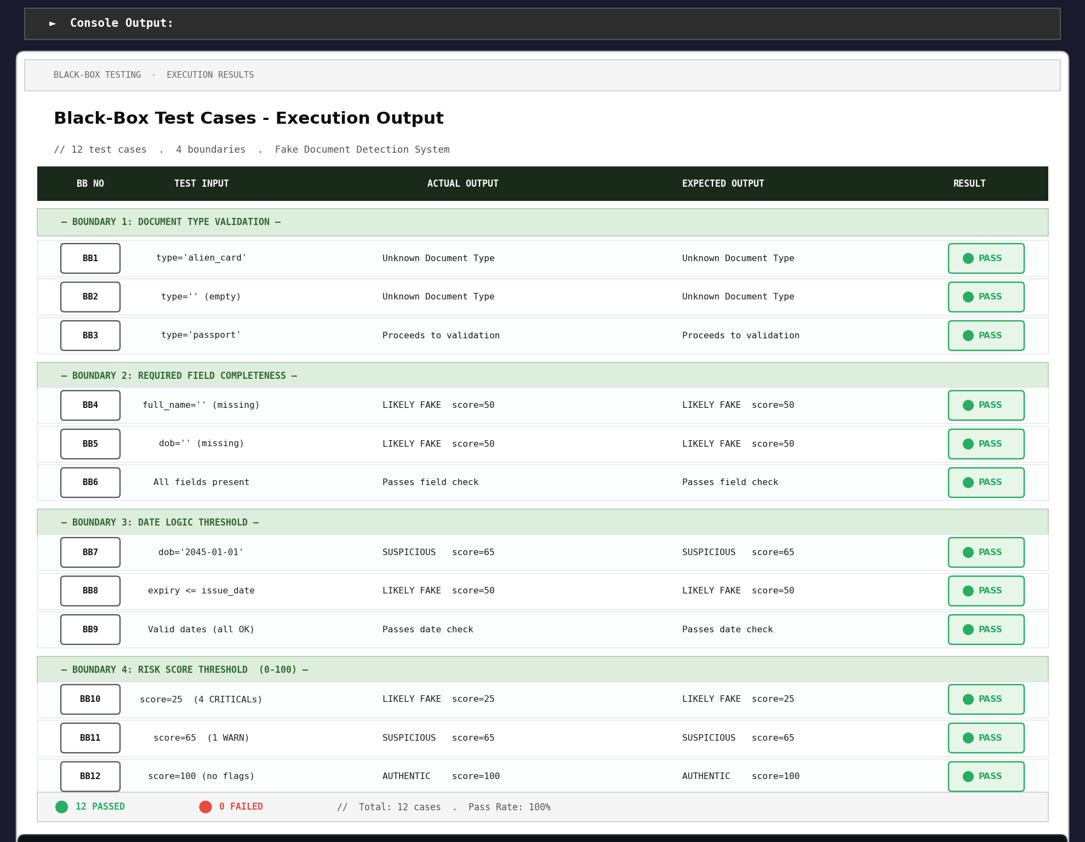
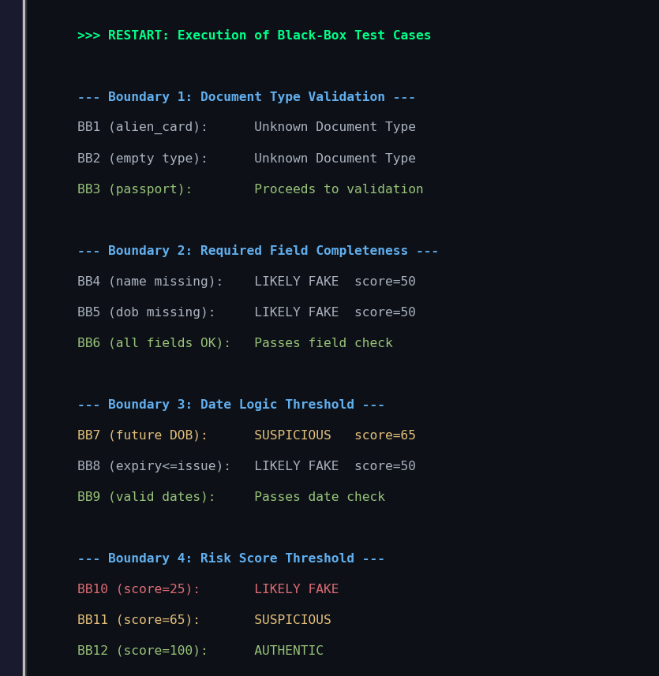
7 Conclusion
- The Software Requirements Specification (SRS) for the Fake Document Detection System provides a comprehensive overview of the system’s objectives, functionalities, and requirements. It clearly defines how the system will operate, the roles of different components, and the interactions between users and the system. The inclusion of UML diagrams such as use case diagrams, sequence diagrams, activity diagrams, and system architecture diagrams helps in visually representing the workflow and structure of the system, making it easier for developers and stakeholders to understand the overall design.
- This document serves as a foundational reference throughout the development process. It ensures that all functional and non-functional requirements are properly defined and understood before implementation begins. By outlining system modules, data flow, and operational processes, the SRS reduces ambiguity and helps maintain consistency during development and testing phases.
- Furthermore, the Fake Document Detection System aims to improve security and reliability by providing a mechanism to identify and prevent the use of fraudulent or manipulated documents. Through proper design and structured development based on this specification, the system can support efficient verification processes and enhance trust in document validation systems.
- Overall, this SRS acts as a guiding document for the successful design, development, and deployment of the Fake Document Detection System, ensuring that the final product meets the intended goals and user requirements.

Designing Elements

- Component-Level Design Elements (ROMS)

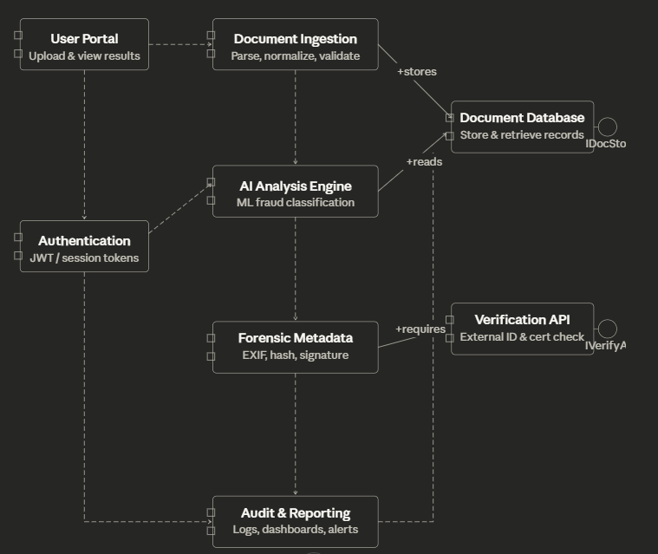
- Component Diagram – ROMS Explanation

• Authentication
It is the entrance gate of the whole system.
Every user (Admin, Verifier, Organization Staff, System Operator) must pass through Authentication before accessing any module.
The dashed arrows indicate that it is connected to multiple modules — meaning all modules depend on Authentication for secure access and control.

• Document Upload & Management
This component handles the uploading, editing, and storage of documents submitted by users.
It receives an arrow from the Document Verification Engine, meaning the verification module depends on it to access uploaded documents.
It connects to the Database (dashed line) to store and retrieve document files and metadata.

• Document Verification Engine
This is the central/core component of the system.
It analyses uploaded documents to detect whether they are genuine or fake using detection algorithms or AI models.
It connects with Document Upload & Management (to obtain documents), Fraud Detection Module, Database, andAuthentication.
It exposes the IDocumentVerificationService interface (+provides) — meaning it provides verification services for other components.
The Database +requires this service to store verification results.

• Fraud Detection Module
Receives analysed data from the Document Verification Engine.
Performs deeper checks such as pattern analysis, anomaly detection, and cross-verification.
Updates the document status (Verified / Suspicious / Fake).
Connected to Notification System via an arrow — indicating that once fraud is detected, alerts are triggered.
Also linked to the Database to read and update verification results.

• Database
Acts as the central data storage for the entire system.
Almost all modules (Document Upload & Management, Document Verification Engine, Fraud Detection Module, Notification System, Reporting and Analytics) interact with it through dashed dependency lines.
It stores documents, verification results, fraud alerts, and user data.
It is linked to the IDocumentVerificationService interface (lollipop symbol) indicating that it requires verification services to manage document data effectively.

• Notification System
Handles sending alerts, notifications, and status updates to users or administrators.
It may send email, SMS, or system notifications when a document is verified or flagged as fake.
Connected to the External NotificationAPI via a dashed arrow — indicating dependency on external services for message delivery.
Also linked with Authenticationand Database.

• External Notification API
This is an external component outside the Fake Document Detection System boundary.
It provides the INotificationService interface (+provides) which offers messaging services such as email or SMS alerts.
The Notification System +requiresthis service to send alerts to users.

• Reporting and Analytics
The final module in the system workflow.
It receives data from the DocumentVerificationEngine and Fraud Detection Module to generatefraud reports, verification statistics, and analytics.
Connected to Authentication — only authorized users (Admin or Supervisors) can access reports.
It relies on verification and fraud detection data to generate meaningful insights.

• IDocumentVerificationService (Interface)
A lollipop interface attached to the Database.
Represents the contract/service provided by the Document Verification Engine for the rest of the system.
Any component requiring document verification data interacts through this interface.

• INotificationService (Interface)
A lollipop interface attached to the External Notification API.
Represents the notification services provided by the external system.
The Notification Systemuses this interface to send alerts and updates.

• Overall Flow Summary
User logs in → Authentication → uploads document via Document Upload & Management → document analyzed by Document Verification Engine → suspicious cases checked by Fraud Detection Module → alerts sent through Notification System → data stored in Database → reports generated in Reporting and Analytics.

- Deployment Level Design Elements(ROMS)
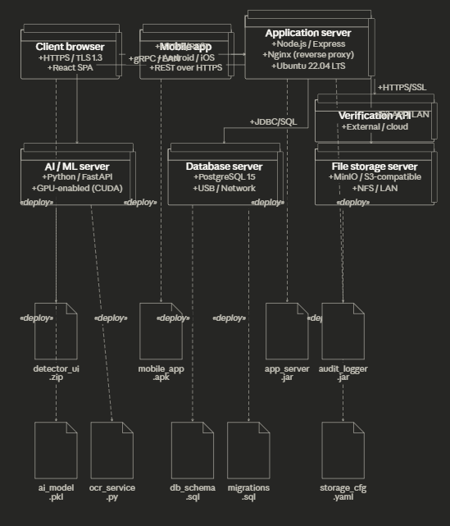
- Deployment Diagram – ROMS Explanation

- Client Browser
The Client Browser is the primary interface through which end users — such as verification officers, auditors, or administrators — access the Fake Document Detection System. It connects to the system remotely via the internet using HTTPS/TLS 1.3, ensuring all communication is encrypted. Two artifacts are deployed and served to this device — detector_ui.zip, which contains the React-based single-page application used to upload documents and view detection results, and audit_dashboard.js, which renders live audit logs and flagged document reports. All document uploads and user interactions are transmitted to the Application Server over HTTPS/REST.

- Mobile App
The Mobile App is a lightweight client application installed on Android or iOS devices, allowing field agents and inspection staff to submit documents for verification on the go. It communicates with the Application Server over REST/HTTPS, making it suitable for remote and low-bandwidth environments. One artifact is deployed on this device — mobile_app.apk, which handles document capture via camera, file upload, and result display. The app sends document images and metadata directly to the Application Server for processing.

- Application Server
The Application Server is the central and most critical component of the Fake Document Detection System. It serves as the backbone that coordinates all communication between the client interfaces, the AI/ML engine, the database, and external services. It runs Node.js with Express for API handling and uses Nginx as a reverse proxy gateway to manage all incoming and outgoing requests. Two artifacts are deployed here — app_server.jar, which contains the core business logic including request routing, session management, and result aggregation, and audit_logger.jar, which records every detection event, user action, and system activity for compliance and traceability. Every client device and backend service communicates through this server.

- AI / ML Server
The AI/ML Server is the intelligence engine of the system and is responsible for performing the actual fake document detection. It runs Python with FastAPI as the inference server and is equipped with a GPU-enabled environment using CUDA to accelerate model execution. Two artifacts are deployed here — ai_model.pkl, which is the trained machine learning model containing learned patterns for detecting forged or tampered documents, and ocr_service.py, which performs Optical Character Recognition to extract text from uploaded document images for further analysis. The Application Server communicates with this server over gRPC on a local area network for low-latency inference requests.

- Database Server
The Database Server is responsible for the persistent storage and management of all data generated and consumed by the system. It runs PostgreSQL 15 as its primary relational database engine, chosen for its reliability and support for complex queries. Two artifacts are deployed here — db_schema.sql, which defines all tables, relationships, indexes, and constraints required by the application, and migrations.sql, which manages incremental schema updates as the system evolves. The Application Server communicates with the Database Server using JDBC/SQL over a secure internal network. All document records, detection results, user accounts, audit logs, and case histories are stored and retrieved from this server.

- File Storage Server
The File Storage Server handles the storage and retrieval of raw document files uploaded by users. It runs MinIO, an S3-compatible object storage system, over NFS/LAN, providing scalable and efficient binary file management. One artifact is deployed here — storage_cfg.yaml, which configures bucket policies, access permissions, and retention rules. When a document is submitted for detection, the Application Server saves the original file to this server and retrieves it when needed for re-analysis or audit review. This separation of file storage from the database ensures performance and scalability.

- External Verification API
The External Verification API is a third-party cloud service used to cross-validate document authenticity against official government or institutional databases. The Application Server communicates with this API over HTTPS/SSL, ensuring all sensitive document data is transmitted securely and in encrypted form. One artifact is deployed as a client adapter — verify_client.jar, which wraps the API calls and handles authentication tokens, rate limiting, and response parsing. When a document is flagged as suspicious by the AI model, a secondary verification request is dispatched to this service to confirm or refute the finding before a final verdict is issued.

- Overall System Flow
When a user uploads a document through the Client Browser or Mobile App, the file is transmitted to the Application Server over HTTPS/REST. The Application Server stores the raw file in the File Storage Server and saves the document metadata in the Database Server via JDBC/SQL. The document is then forwarded to the AI/ML Server over gRPC, where ocr_service.py extracts text and ai_model.pkl performs fraud classification. If the document is flagged as suspicious, the Application Server dispatches a cross-check request to the External Verification API over HTTPS/SSL. The final detection verdict — authentic or forged — is stored back in the Database Server and returned to the user interface in real time. Throughout the entire process, audit_logger.jar records every action, and all document records remain continuously accessible for review and compliance reporting.

Metrics for Analysis Model

Based on the Software Requirement Specification (SRS) for the Fake Document Detection System, the Unadjusted Function Point (UFP) is calculated by identifying and weighting the system's functional components: External Inputs (EI), External Outputs (EO), External Inquiries (EQ), Internal Logical Files (ILF), and External Interface Files (EIF).
For this calculation, standard "Average" complexity weights are applied: EI (4), EO (5), EQ (4), ILF (10), and EIF (7).

1. External Inputs (EI)
These are processes that capture or update data from outside the system boundary into internal files.
● User Registration: Adds new user details into the system database.
● User Login: Accepts credentials for authentication and access.
● Upload Document: Users upload documents (PDF/Image) for verification.
● Submit Verification Request: Sends uploaded files for processing and analysis.
● Admin Document Management: Admin uploads or updates sample/reference documents.
● Update User Details: Users or admins modify profile information.
● Total EI Count: 6

2. External Outputs (EO)
These are processes that generate and send processed or calculated data outside the system.
● Detection Result Output: Displays whether the document is real or fake.
● Similarity/Confidence Score Report: Shows percentage accuracy or match score.
● Fraud Alert Notification: Alerts users/admins if a document is detected as fake.
● Report Generation: Generates downloadable verification reports.
● Total EO Count: 4

3. External Inquiries (EQ)
These are processes that retrieve data without modifying system data or performing complex processing.
● View Verification History: Displays previously checked documents.
● Check Document Status: Retrieves current processing status of uploaded files.
● View Guidelines/Instructions: Provides information on valid document formats.
● Search Documents: Retrieves stored document records based on filters.
● Total EQ Count: 4

4. Internal Logical Files (ILF)
These are logically related data groups maintained within the system.
● User Database: Stores user credentials and profile details.
● Document Repository: Stores uploaded documents and related metadata.
● Verification Results Database: Stores detection outcomes and confidence scores.
● Reference Dataset: Stores genuine and fake document samples used for comparison/training.
● Total ILF Count: 4
CALCULATION OF UFP

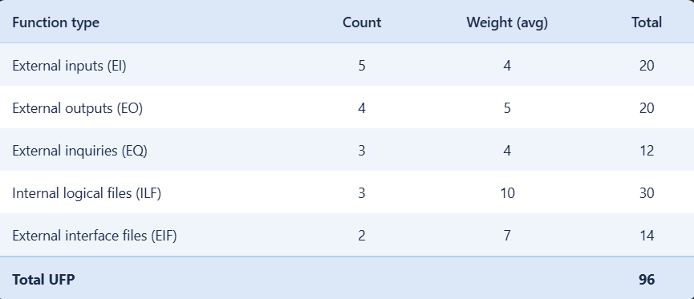

Calculation of Complexity Adjustment Factor (CAF)
The Complexity Adjustment Factor (CAF) is determined based on fourteen General System Characteristics (GSCs), each evaluated on a scale from 0 (no influence) to 5 (strong influence).
For the Fake Document Detection System, a moderate to slightly higher level of influence is considered due to features such as document processing, pattern recognition, security checks, and report generation. Hence, the total degree of influence is estimated as 38.
$$CAF=0.65+(0.01×38) \\ CAF=0.65+0.38=1.03$$

Final Result:
Complexity Adjustment Factor (CAF) = 1.03

Calculation of Functional Point (Path 1)

Step 1: Calculation of UFP Value
The total Unadjusted Function Points (UFP) for the system is calculated based on identified components:
UFP = 114

Step 2: Complexity Adjustment Factor (CAF)
From the previous calculation:
CAF = 1.03

Step 3: Final Functional Point (FP)
$$FP=UFP×CAF \\ FP=114×1.03=117.42$$

Final Result
Functional Points (FP) = 117.42 = 117

Cost Estimation (Based on COCOMO Effort)

Step 1: Effort Estimation
From the previous COCOMO calculation:
Effort = 15.20 Person-Months (PM)

Step 2: Cost per Person-Month
Assuming the average cost of one person per month is:
Cost per PM = ₹15,000

Step 3: Total Project Cost
$$Total Cost=Effort ×Cost Per PM$$
$$TotalCost=15.20×15000 \\ TotalCost=\text{₹}2,28,000$$

Final Result
Total Estimated Cost of the Project = ₹2,28,000

10 Empirical Estimation Models (COCOMO)

- Project Baseline
• Function Points (FP) = 142.35 (adjust if your calculated FP is different)
• Conversion used: 1 FP ≈ 10 Lines of Code (LOC) [standard conversion]
• LOC = 142.35 × 10 = 1,423.50
• KLOC = 1,423.50 / 1000 = 1.423 KLOC
• Project Type: Organic — small team, well-understood requirements, familiar environment (machine learning-based document verification system)

- Basic COCOMO Model
The Basic COCOMO model uses only KLOC to estimate effort and time. It is used for a quick, rough calculation of software cost.
Formula:
E = A × (KLOC)^B
T = C × (Effort)^D
Persons = Effort / Time
Constants for Organic project type (from lab manual):
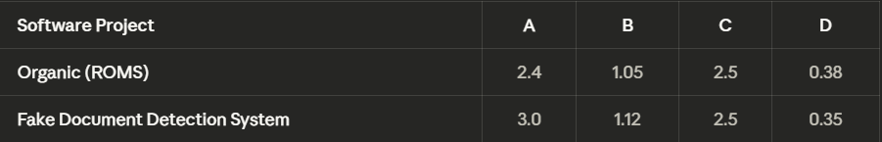
• Effort Estimation:-
Formula: E = A × (KLOC)^B = 3.0 × (KLOC)^1.12
E = 3.0 × (1.423)^1.12
= 3.0 × 1.483
= 4.45 Person-Months (PM)

• Development Time Estimation:-
Formula: T = C × (Effort)^D = 2.5 × (E)^0.35
T = 2.5 × (4.45)^0.35
= 2.5 × 1.686
= 4.22 Months

• Persons Required:-
Formula: Persons = Effort / Time
Persons = 4.45 / 4.22
= 1.05 ≈ 1 Person

• Total Project Cost:-
Assuming: Cost per Person-Month = ₹15,000
Cost = Effort × Cost per PM
= 4.45 × ₹15,000
= ₹66,750

• Basic COCOMO Results Summary

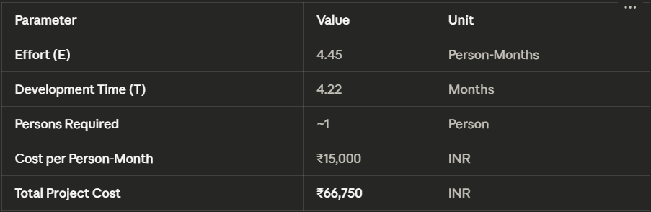
- Intermediate COCOMO Model
The Intermediate COCOMO model refines the Basic model by multiplying the base effort by an Effort Adjustment Factor (EAF). The EAF is the product of 15 Cost Driver ratings that reflect real project characteristics. For Fake Document Detection System, the constant A is taken as 3.0.
Formula:
E = (A × (KLOC)^B) × EAF where A = 3.0, B = 1.12
T = C × (Effort)^D where C = 2.5, D = 0.35
EAF = Product of all 15 cost driver values

• Cost Driver Ratings for Fake Document Detection System
Each cost driver is rated on the scale: Very Low / Low / Nominal / High / Very High / Extra High. A Nominal rating carries a value of 1.00 and has no effect on effort. Values above 1.00 increase effort; values below 1.00 decrease it.

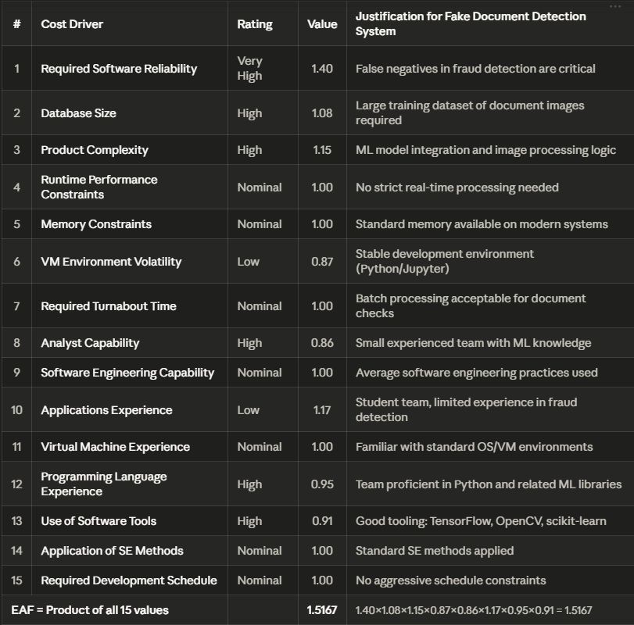
•EAF Calculation:-
Formula: EAF = Product of all 15 cost driver values
EAF = 1.40 × 1.08 × 1.15 × 1.00 × 1.00 × 0.87 × 1.00 × 0.86 × 1.00 × 1.17 × 1.00 × 0.95 × 0.91 × 1.00 × 1.00
= 1.5167

•Effort Estimation (Intermediate Model):-
Formula: E = (A × (KLOC)^B) × EAF
E = (3.0 × (1.423)^1.12) × 1.5167
= (3.0 × 1.483) × 1.5167
= 4.45 × 1.5167
= 6.75 Person-Months (PM)

•Development Time Estimation:-
Formula: T = C × (Effort)^D
T = 2.5 × (6.75)^0.35
= 2.5 × 1.949
= 4.87 Months

•Persons Required:-
Formula: Persons = Effort / Time
Persons = 6.75 / 4.87
= 1.38 ≈ 1–2 Persons

•Total Project Cost:-
Assuming: Cost per Person-Month = ₹15,000
Cost = Effort × Cost per PM
= 6.75 × ₹15,000
= ₹1,01,250
• Intermediate COCOMO Results Summary
